|  |  |
| --- | --- |
| EGC_Black | Student Name \_\_\_\_\_\_\_\_\_\_\_\_\_\_\_\_\_\_\_\_\_\_\_    **Eastern Goldfields College**  Mathematics Applications U3&4 2016  Test 3 1– Calculator Free Section |
| **Working Time: 32 minutes** | **Total Marks: 29 marks** |

**Question 1 [7 marks: 2, 1, 2, 2]**

A tree graph is a planar graph with no cycles. It is an undirected graph in which any two vertices are connected by exactly one path. The following questions all refer to tree graphs.

a) For the following trees state the number of vertices and the number of edges.

i) ii)



Edges = \_\_\_\_\_\_\_\_\_\_\_\_\_\_\_\_ Edges = \_\_\_\_\_\_\_\_\_\_\_\_\_\_\_\_

Vertices = \_\_\_\_\_\_\_\_\_\_\_\_\_\_ Vertices = \_\_\_\_\_\_\_\_\_\_\_\_\_\_

b) Draw a tree with 4 vertices and 3 edges.

c) Is it possible to draw a tree with 4 vertices and 5 edges? Explain your answer.

d) Use the tree in part a) i) above and Euler’s formula to explain why tree graphs are all planar.

**Question 2 [8 marks: 5, 1, 2]**

1. 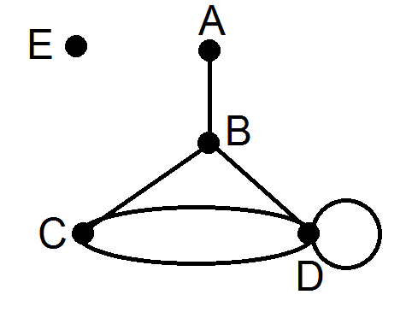Consider the graph on the right.  
   1. Which vertex is adjacent to A?
   2. The loop in the graph connects which vertex to itself?
   3. Which pair of vertices is connected by multiple edges?
   4. Is this a connected graph? Explain.

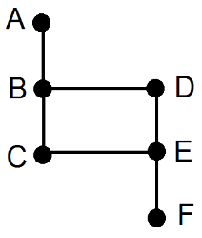

1. Draw a sub-graph of the graph on the right.

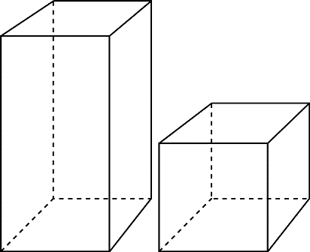

1. Represent the following three-dimensional prism as a planar graph.

**Question 3 [6 marks: 2, 2, 2]**

In a netball competition there are four teams participating.

a) If every team needs to play each other exactly once, how many games are required for the season?

b) Draw the graph showing how each team can play each other, what type of graph would this be?

c) If two more teams join the competition how many more games are required to be played in order for each team to still play each other exactly once?

**Question 4 [3 marks: 1, 2]**

A treasure hunt is being organised and a graph showing where prizes are hidden is shown below.



a) Show a semi-Hamiltonian cycle which you could walk in order to collect all the prizes.

b) Is it possible to create a Eulerian cycle for the treasure hunt by adding exactly one path? If so, show the path on the graph above.

**Question 5 [8 marks: 2, 2, 2, 1, 1]**

A tabloid magazine is comparing the amount of time some famous mothers spend on washing, cleaning and shopping per week.

Marg spends 3 hours on washing, 5 hours shopping and 9 hours cleaning each week. Bec spends, 6 hours on washing, 6 hours shopping and 3 hours cleaning each week and Kate spends 2 hours washing, 3 hours shopping and 4 hours cleaning each week.

1. Complete the following matrix showing the time (in hours) spent by each of the three mothers on these tasks each week. The rows in order represent the three mothers, Marg, Bec and Kate. The columns in order represent the tasks, washing, shopping and cleaning.

1. Present the matrix from part a) as a labeled and weighted bipartite graph.
2. Is this bipartite graph complete or incomplete? Explain.
3. Who spends the most time cleaning?
4. What is the total amount of time Bec spends on all these tasks?

|  |  |
| --- | --- |
| EGC_Black | Student Name \_\_\_\_\_\_\_\_\_\_\_\_\_\_\_\_\_\_\_\_\_\_\_    **Eastern Goldfields College**  Mathematics Applications U3&4 2016  Test 3 1– Calculator Assumed Section |
| **Working Time: 20 minutes** | **Total Marks: 17 marks** |

**Question 1 [4 marks: 2, 2]**

Consider the following undirected graph.



1. Construct the adjacency matrix, *M*, for the above digraph.
2. Calculate *M*2and explain the significance of the zero elements in this matrix.

**Question 2 [2 marks]**

Is it possible to construct a traversable network through the following diagram of islands and bridges?

If your answer is no, justify your solution and add one extra bridge which would make the network traversable. If your answer is yes, clearly show the traversable path.

**B**



**A**

**D**

**C**

**Question 3 [11 marks – 4, 1, 6]**

The following network shows some of the corridors running through a large hospital. Most of the thoroughfare through this hospital is from A to E.

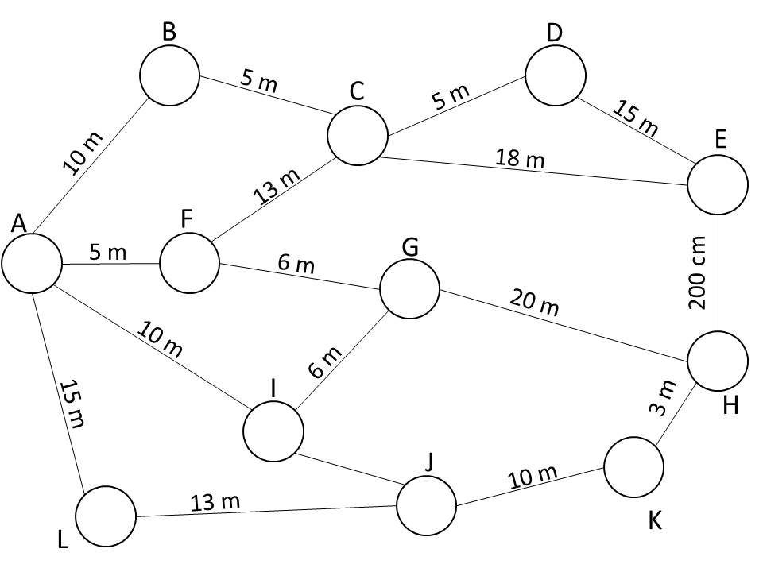The hospital receives some funding to upgrade some of the finishings in the corridors. In order to maximise their budget they decided to upgrade the shortest path from A to E as these would be the most used corridors. The cost of upgrading is $95/metre.

1. What is the shortest distance from A to E and what is this pathway?

1. What is the cost of upgrading the shortest path from A to E?

Upon further discussions it appears that not all the corridors require the same amount of work to upgrade and therefore the costs of upgrading each corridor are not equal. The following table shows the multiplication factor in the costs of upgrading each corridor relative to the lengths.

|  |  |  |  |  |  |  |  |  |  |  |  |  |
| --- | --- | --- | --- | --- | --- | --- | --- | --- | --- | --- | --- | --- |
|  | A | B | C | D | E | F | G | H | I | J | K | L |
| A |  | 1 |  |  |  | 1.9 |  |  | 0.3 |  |  | 0.1 |
| B | 1 |  | 1.2 |  |  |  |  |  |  |  |  |  |
| C |  | 1.2 |  | 0.9 | 1 | 0.2 |  |  |  |  |  |  |
| D |  |  | 0.9 |  | 1.1 |  |  |  |  |  |  |  |
| E |  |  | 1 | 1.1 |  |  |  |  |  |  |  |  |
| F | 1.9 |  | 0.2 |  |  |  | 1.6 | 1 |  |  |  |  |
| G |  |  |  |  |  | 1.6 |  | 2 | 0.1 |  |  |  |
| H |  |  |  |  | 1 |  | 2 |  |  |  | 0.2 |  |
| I | 0.3 |  |  |  |  |  | 0.5 |  |  | 0.3 |  |  |
| J |  |  |  |  |  |  |  |  | 0.3 |  | 0.6 | 0.1 |
| K |  |  |  |  |  |  |  | 0.2 |  | 0.6 |  |  |
| L | 0.1 |  |  |  |  |  |  |  |  | 0.1 |  |  |

1. Taking into account the multiplication factors, which path from A to E should the hospital upgrade in order to minimise costs? Clearly state this path and the total cost of upgrading it. Use the blank network below to assist with your answer.

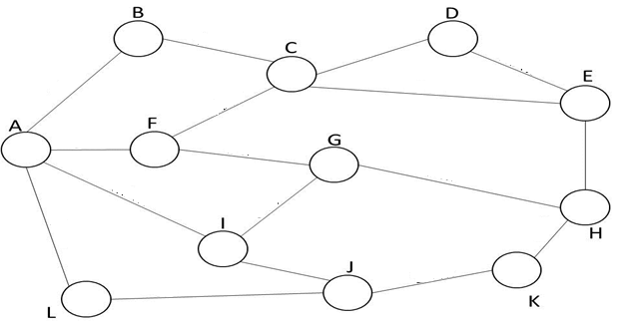

**END OF TEST**